Error : husky > Setting up git hooks

git rev-parse command failed. Got fatal: not a git repository (or any of the parent directories): .git

husky > Failed to install

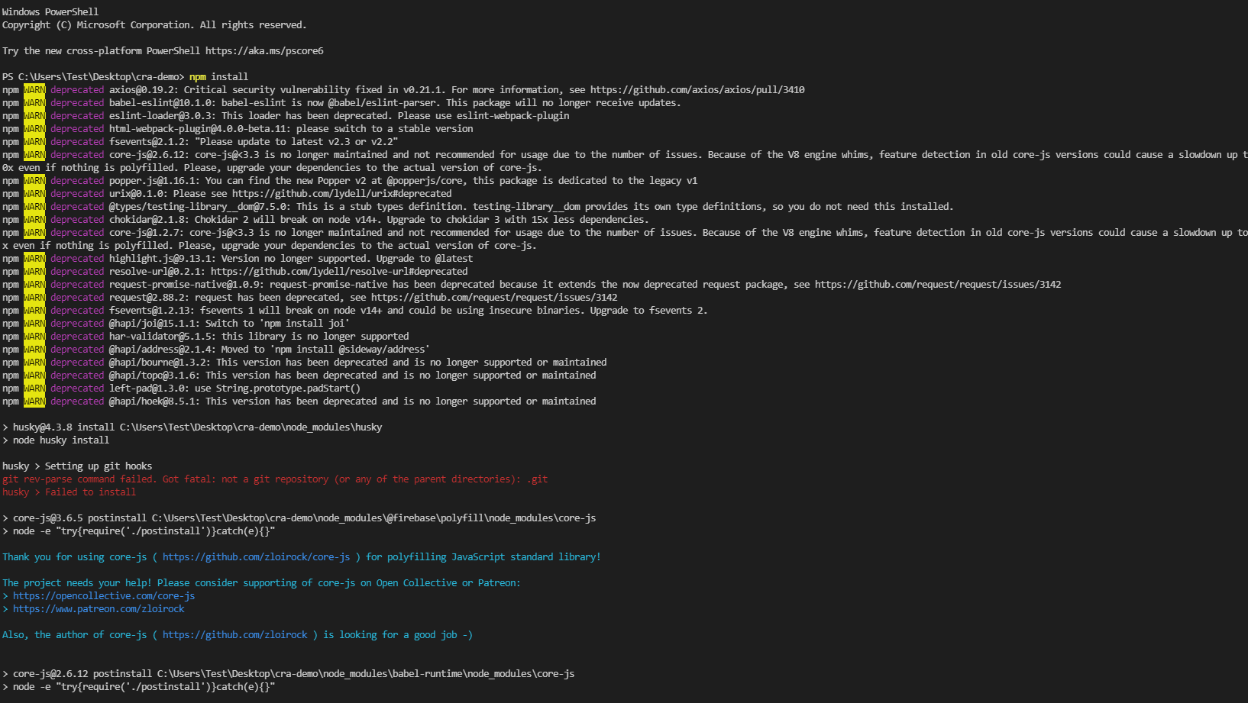

Fix erro : git clone git://cfdem.git.sourceforge.net/gitroot/cfdem/liggghts

Cloning into 'liggghts'...

